DATA VISUALIZATION USING MATPLOTLIB

import matplotlib.pyplot as plt

# initializing the data
x = [10, 20, 30, 40]
y = [20, 30, 40, 50]

# plotting the data
plt.plot(x, y)

# Adding the title
plt.title("Simple Plot")

# Adding the labels
plt.ylabel("y-axis")
plt.xlabel("x-axis")
plt.show()

#intializing data For BAR&PIE Chart
x = [ 25, 50, 36, 19]
y = ['Neural Network', 'Data analytics', 'Quantum Computing', 'Machine Learning']

#Bar graph
plt.bar([0.25,2.25,3.25,5.25,7.25],[300,400,200,600,700],
label="Y axis",color='b',width=0.5)
plt.bar([0.75,1.75,2.75,3.75,4.75],[50,30,20,50,60],
label="X axis", color='g',width=.5)
plt.legend()
plt.xlabel('Course')
plt.ylabel('Strudents ')
plt.title('Bar graph')
plt.show()

#pie chart
plt.pie(x, labels=y)
plt.title("Pie Chart")
cols = ['b','c','g', 'orange']
plt.pie(x,
labels =y,
colors = cols,
startangle = 90,
shadow = True,
explode =(0.1,0,0,0),
autopct ='%1.1f%%')

plt.show()

OUTPUT:
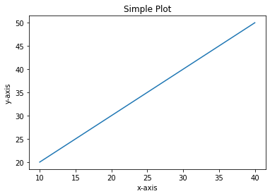

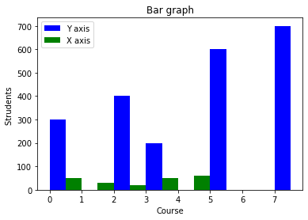

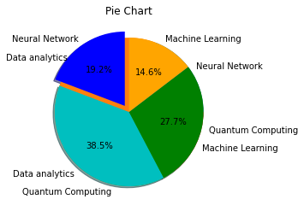

HISTOGRAM AND SCATER PLOT
#Histogram
import matplotlib.pyplot as plt
# data to display on plots
x = [ 2, 3, 4, 5, 6, 7, 4]
y = [8, 8.5, 9, 9.5, 10, 10.5, 11]
# This will plot a simple histogram
plt.hist(x,)
# Title to the plot
plt.title("Histogram")
# Adding the legends
plt.legend(["bar"])
plt.show()

#Scatter plot

plt.scatter(x,y,label='Values of x&y',color='r')
plt.title('Smart Band Data Report')
plt.xlabel('x')
plt.ylabel('y')
plt.legend()
# Print the chart
plt.show()



